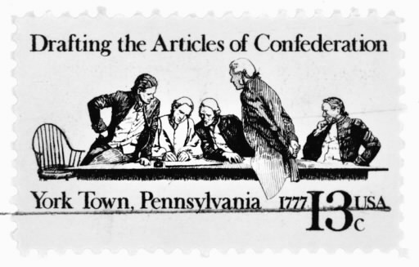
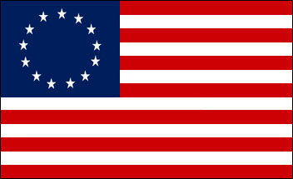
SS8H4a Analyze the strengths and weaknesses of both the Georgia Constitution of 1777 and the Articles of Confederation and explain how weaknesses in the Articles of Confederation led to a need to revise the Articles.

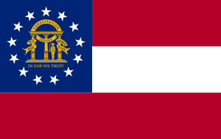

GEORGIA CONSTITUTION
OF 1777

STRENGTHS
Georgia could rule itself and not have to be governed by the British King and Parliament.

Separation of powers in government. Legislative branch made the laws while the executive branch enforced them, and the judicial branch settled disputes.

Georgians were guaranteed freedom of speech, assembly, religion, and trial by jury.

Parishes were turned into counties and each county had its own local government and representatives; and militia, school, and courts.

WEAKNESSES
Before Georgians declared independence they were governed by James Oglethorpe, the Trustees, and eventually royal governors appointed by the King of England. These people represented the executive branch of government. When Georgia declared independence and created their own constitution they intentionally created a government that had a weak executive branch and a strong legislative branch so that one person would not have too much power.

They legislative branch was so strong that it not only made the laws in Georgia, but also appointed (selected) the Governor as well as the judges. This is considered a weakness because too much power was in the hands of only one branch of government. In addition, Georgia was a uni-cameral legislature called the House of Assembly which made it easier to create and pass laws. That is a negative because there is little opposition.

Another weakness is that not everyone could vote or represent the people in government. Only white males, age 21 and older with property could participate in government.

Finally, the Georgia Constitution was very hard to amend (change)

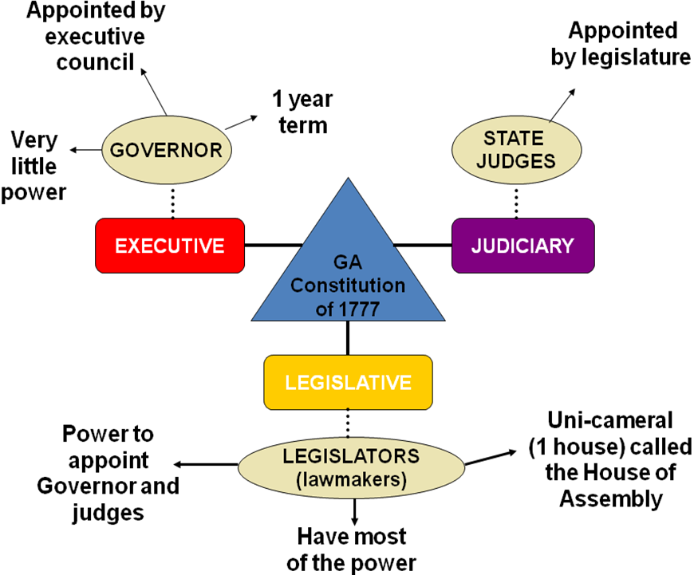

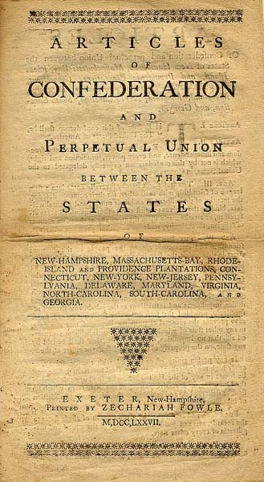
ARTICLES OF CONFEDERATION

WEAKNESSES
The flag above shows the 13 colonial stripes along with the 13 states united together in a circle. However, once the Revolutionary War ended the states basically acted like 13 independent countries and really didn’t unite together at all.

There were able to do this because the Articles of Confederation gave the states most of the power by intentionally creating a weak national government. The last thing Americans wanted was a national government telling them what to do, taxing them unfairly, and taking away their rights.

States had too much power and began to get into conflicts with other states and the national government didn’t have any power to keep the states united together. For example, the federal government could not levy taxes, therefore, the US government did not have any money to create an army to protect the young nation from Indian or foreign attacks or rebellions in the states, nor could they provide economic help to struggling states. The US government also could not regulate trade and each state issued its own currency which also made trade difficult.

The national government could not enforce any laws because under the Articles of Confederation there was no executive branch, nor was there a President. Also, there was not a judicial branch and not a Supreme court to help settle disputes between the states. States argued over boundary lines and taxed each other over trade (tariff). Congress had a uni-cameral legislature and each state received 1 vote regardless of their population size. Lastly, it was difficult to amend or change the Articles of Confederation since all 13 states had to unanimously agree.

STRENGTHS
Because the 13 independent states needed to unite together and defend themselves from Great Britain they had to create a national (central or federal) government. This is known as Federalism.

The Articles of Confederation served as the 1st constitution for the states after they declared independence from Great Britain. The Articles gave power to a national Congress to declare war, sign treaties, deliver mail, and to create money. During the Revolutionary War states did a good job of providing Congress with what it needed to fight the British. However, there were many weaknesses to the Articles of Confederation.

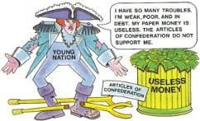
13 states with more power than the central government

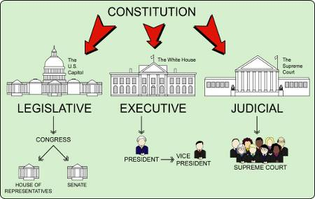
SS8H4b Describe the role of Georgia at the Constitutional Convention of 1787; include the role of Abraham Baldwin and William Few, and reasons why Georgia ratified the new constitution.
MAKES
LAWS
INTERPRETS
LAWS
CONSTITUTIONAL CONVENTION OF 1787
US citizens realized that having too much power in state government was hurting the national government and country as a whole. To solve this problem each state sent delegates (representatives) to Philadelphia in 1787 to revise (improve) the Articles of Confederation. Abraham Baldwin and William Few were delegates who represented Georgia. After weeks of debates the Founding Fathers agreed that a new constitution was needed to be written that gave more power to the federal government. In order to be effective the national government needed the power to levy and collect taxes in order to have money to operate a working government and a military.

The US government also needed an Executive branch that had the power to enforce laws. The national government also needed a judicial branch with judges and a court that could settle disputes between the states. The new constitution created three branches of government that were equal in power. Each branch had certain powers that kept the other two powers in check. This was called Checks and Balances.

The problem at the Constitutional Convention was getting states to agree on certain issues. For example, states with large populations like Virginia wanted more representation in government, not just one vote which all states under the Articles of Confederation received, even states with small populations. Eventually, the Great Compromise created a bi-cameral legislature that allowed states to be represented based on their population in the House of Representatives which satisfied the big states, while small states were happy with each state being able to send two representatives to the Senate House.

Another problem was the issue of slavery. Northern states wanted to ban slavery, but the southern states threatened to not sign the constitution because their economy and way of life depended on slave labor, even though it was immoral and wrong. To avoid this conflict the states agreed to the 3/5th Compromise which allowed the southern states to count 3 out of 5 slaves as population which helped increase their representation in the bi-cameral legislature. However, the southern states had to pay taxes on those slaves they counted toward their population.

States also wanted to guarantee the rights of citizens and their individual liberties, so it was promised that a Bill of Rights would be amended to the constitution, which they were in 1791.

ENFORCES
LAWS

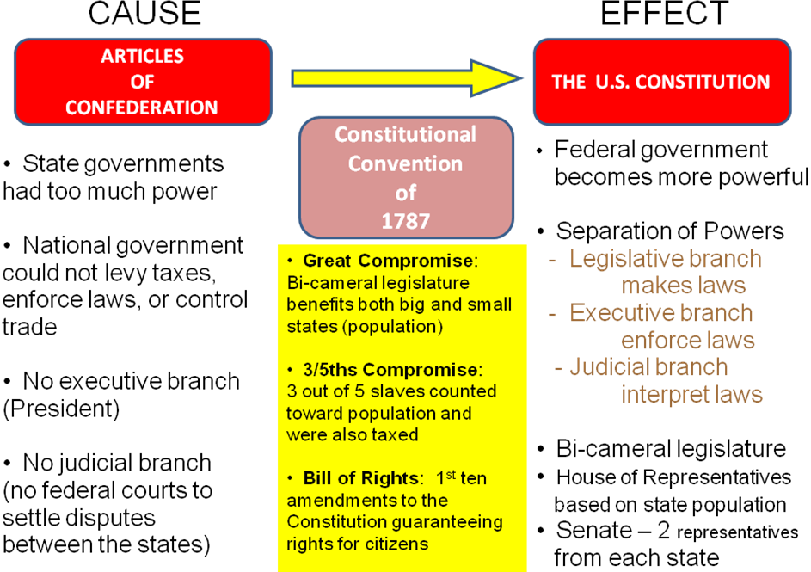

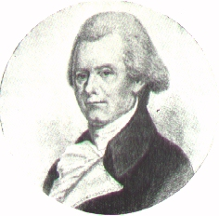
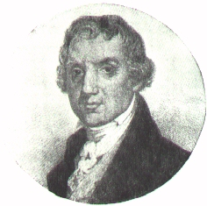
ABRAHAM
BALDWIN
WILLIAM
FEW
As delegates from Georgia, both Abraham Baldwin and William Few participated in the Constitutional Convention of 1787 and signed the Constitution. William Few helped write the Constitution and Abraham Baldwin’s key vote help create the Great Compromise which created a bi-cameral legislature.

REASONS FOR RATIFYING THE US CONSTITUTION
Like most states, Georgia wanted to ratify (approve) the new US Constitution because they realized the individual states could not survive unless they were united together with a stronger national government. On January 2nd, 1788 Georgia was the 4th state to ratify the constitution.
Another reason why Georgia ratified the Constitution was the need for the United States government to help the state of Georgia expand westward into Indian territories. The US government could create laws, sign treaties, or help Georgia by providing military enforcements to fight the Native Americans.

